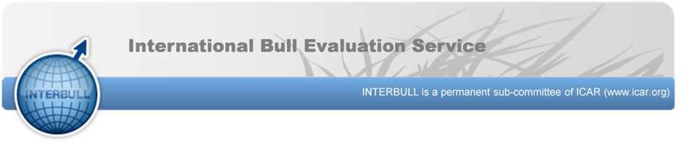Expression of Interest
Interbull Technical Committee
PERSONAL INFORMATION
Name:
Position:
Organisation:
Address:
Mobile number:
Email:
COMMITTEES
What attributes would you bring to the Interbull Technical Committee?

How would you add value to the Interbull Technical Committee in relation to the following topics:
Genetic Supply Chain
Genetic Evaluation systems
Genetic Evaluation Units
Research, Development and Extension
Data Management and Technology
Phenotypic data collection services

Brief Biography:

Why would you like to be on the Interbull Technical Committee?

Please send the completed Expression of Interest and your CV to Simone.Hazas@slu.se, with subject: ‘Expression of Interest - Interbull Technical Committee’ by no later than 28 February 2024.

